TASK #01:

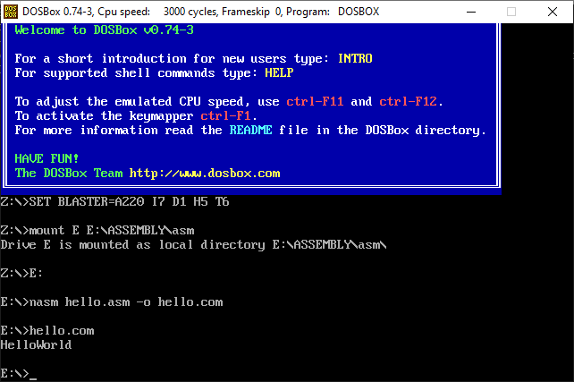bits 16

org 100h

section .data

name db 'Hello World', 0ah, 0dh, '$'

mov dx, name

mov ah, 09h

int 21h

; Terminate Program

mov ah, 4Ch

int 21h

TASK #02:

bits 16

org 100h

section .data

name db 'Hello from nasm', 0ah, 0dh, '$'

section .text

main:

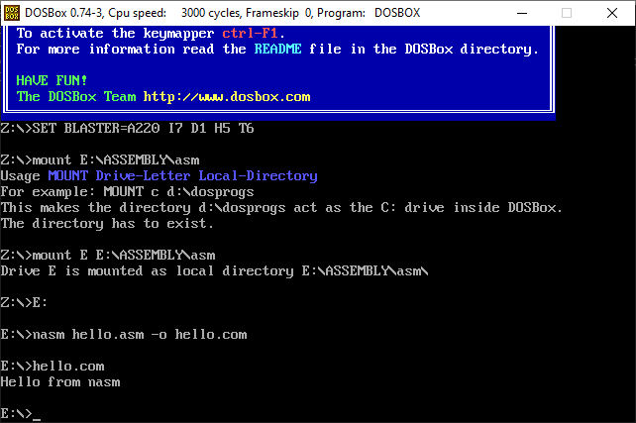 ; Print Name

mov dx, name

mov ah, 09h

int 21h

; Terminate Program

mov ah, 4Ch

int 21h

TASK #03:

bits 16

org 100h

section .data

name db 'John Doe', 0ah, 0dh, '$'

roll_number db 'Roll No: 12345', 0ah, 0dh, '$'

department db 'Department: Computer Science', 0ah, 0dh, '$'

section .text

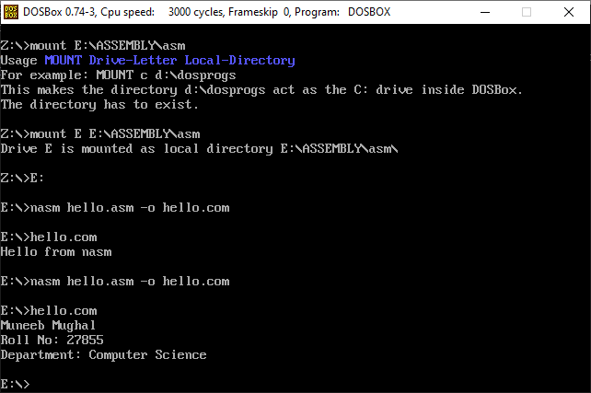 main:

; Print Name

mov dx, name

mov ah, 09h

int 21h

; Print Roll Number

mov dx, roll_number

mov ah, 09h

int 21h

; Print Department

mov dx, department

mov ah, 09h

int 21h

; Terminate Program

mov ah, 4Ch ; DOS function: terminate program

int 21h ; Call DOS interrupt